GA4 Campaign Implementation & Analysis Report
Course: Digital Marketing / Web Analytics
Tool Used: Google Analytics 4 (GA4), Microsoft Clarity, Nelio A/B Testing
Website: Google Merchandise Store (Demo Account)

1. Campaign Landing Page & UTM Tracking
To track campaign performance accurately, UTM parameters were added to the campaign landing page URLs and shared across different platforms.

UTM-Tagged Campaign URLs
URL 1 – Social Media Campaign (Instagram / Facebook):
https://shehryar-04.github.io/free-website-audit/?utm_source=whatsapp&utm_medium=message&utm_campaign=free+website+audit
URL 2 – Email Marketing Campaign:
https://shehryar-04.github.io/free-website-audit/?utm_source=instagram&utm_medium=reels&utm_campaign=free+website+audit
Purpose:
These UTM parameters allow GA4 to identify traffic source, medium, and campaign performance, enabling accurate attribution and comparison between marketing channels.

GA4 Data Stream Screenshot
- 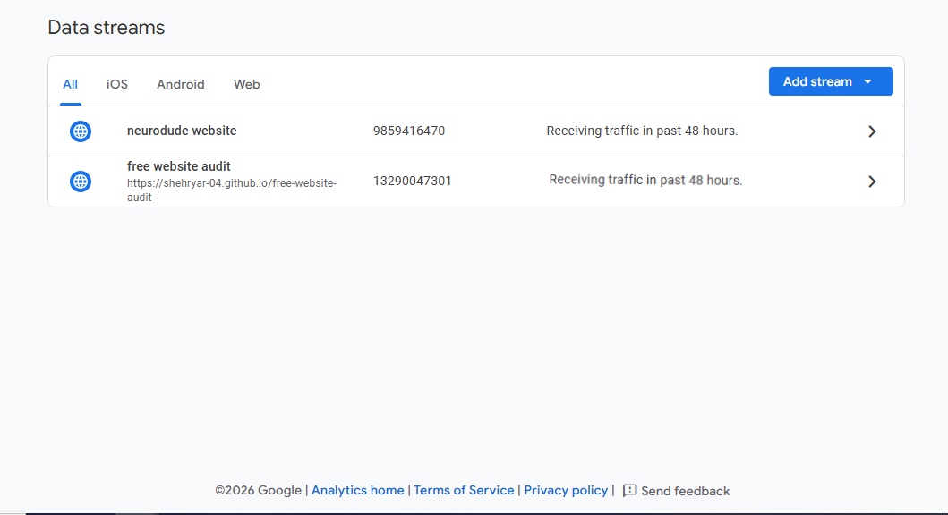
Navigation Path:
GA4 → Admin → Data Collection and Modifications → Data Streams
Explanation:
The data stream confirms that GA4 is actively collecting data from the website, including events, user activity, and engagement metrics.

3. Microsoft Clarity Plugin Screenshot (To Be Added)
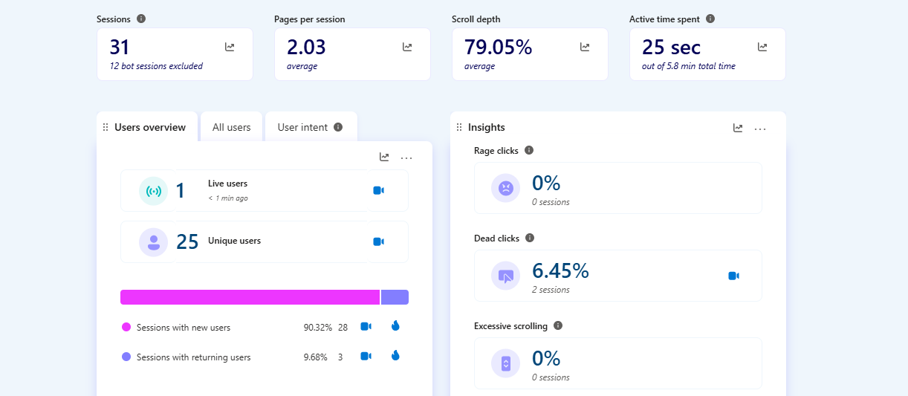Explanation:
Microsoft Clarity was used to analyze qualitative user behavior through heatmaps, session recordings, and scroll depth, complementing GA4’s quantitative data.

4. A/B Testing Screenshots – Nelio A/B Testing (To Be Added)

Original Landing Page

Variant Landing Page
Explanation:
Nelio A/B Testing was used to compare the performance of two landing page versions to identify which design and messaging resulted in higher engagement and conversions.

5. Analysis of the Google Merchandise Store Demo Account (GA4)

Engagement Analysis, User Attributes, and Marketing Strategy

5.1 Traffic Acquisition Analysis
The Traffic Acquisition report in GA4 was analyzed to identify the channels generating the highest traffic and new user acquisition.

Traffic Volume by Channel
Direct: 18,000 sessions
Organic Search: 17,000 sessions
Paid Search: 5,200 sessions
Unassigned: 5,200 sessions
Insight:
Direct and Organic Search are the dominant traffic drivers, indicating strong brand awareness and effective search engine optimization (SEO). Users are intentionally visiting the site or discovering it through unpaid search results.

New User Acquisition
Direct: 11,000 new users
Organic Search: 10,000 new users
Paid Search: 3,400 new users
Insight:
Direct and Organic Search are also effective in attracting first-time visitors, while Paid Search plays a secondary but important role.

5.2 Engagement Analysis
Engagement metrics were used to assess the quality of traffic.

Key Engagement Metrics
Engagement Rate: 56.38%
Engaged Sessions per Active User: 0.81
Average Engagement Time: 1 minute 33 seconds
User Key Event Rate: 28.58%
Total Revenue: $123,643.50
Insight:
Engagement metrics provide deeper insights than traffic volume alone, as they indicate meaningful interactions and conversion potential.

Engagement Observations
Direct and Organic Search are likely the most engaged channels due to their high traffic and revenue contribution.
Paid Search attracts fewer users but is typically conversion-focused and useful for targeted campaigns.
Lower-volume channels such as Email and Referral may have niche audiences but limited overall impact.

5.3 User Attributes Analysis

Geographic Insights
United States
54.41% of active users
89.37% of total revenue
Highest engagement (1 minute 56 seconds average engagement time)
Insight:
The United States represents the most valuable user segment, combining high traffic, strong engagement, and high purchasing behavior.
India
15.02% of users
0.55% of total revenue
Lower engagement time (59 seconds)
Insight:
Indian users demonstrate interest but low conversion, indicating price sensitivity or non-purchase intent.
Canada
Smaller user base with strong engagement and revenue contribution.
China
Very low engagement (10.38% engagement rate) and no revenue.

6. Marketing Strategy Recommendations

What Should a Marketer Do?
Based on the analysis of traffic sources, engagement levels, and user demographics, a balanced marketing strategy should be adopted that both capitalizes on successful channels and improves underperforming ones.

Focus on Successful Channels
Priority should be given to Direct and Organic Search, as these channels consistently deliver high traffic, strong engagement, and the majority of revenue.
Actions:
Continue investing in SEO strategies, including content optimization and keyword targeting.
Strengthen brand visibility and loyalty through consistent branding and remarketing campaigns.
Optimize landing pages for high-intent organic and direct visitors to maximize conversions.

Improve Underperforming Channels
Underperforming channels such as Paid Search, Email, and traffic from certain regions should be refined rather than eliminated.
Actions:
Improve Paid Search targeting by focusing on high-intent keywords and users from high-converting regions (US and Canada).
Test different ad creatives and promotional offers to improve engagement and conversion rates.
Analyze Unassigned traffic to improve channel attribution accuracy.

Adjust Messaging and Targeting Based on Demographics
United States & Canada: Use premium, product-focused messaging and promote exclusive or limited-edition merchandise.
India: Use awareness-based messaging, highlight affordability and discounts, and focus on long-term brand building.
China: Investigate traffic quality and technical accessibility issues before investing further.

7. Conclusion
The GA4 analysis demonstrates that the Google Merchandise Store benefits most from Direct and Organic Search traffic and users located in North America. A data-driven marketing strategy that prioritizes high-performing channels and regions while optimizing underperforming segments can significantly improve engagement, conversions, and revenue.

Note: Screenshots and visual evidence will be added in the indicated sections prior to final submission.

